Q) Reversing of an array.

=> #include <iostream>

using namespace std;

int main()

{

int a[]={52,22,34,11,5};

int b[5];

for(int i=0,j=4;i<5,j>=0;i++,j--)

{

b[i]=a[j];

}

for(int i=0;i<5;i++)

{

cout<<b[i]<<endl;

}

}

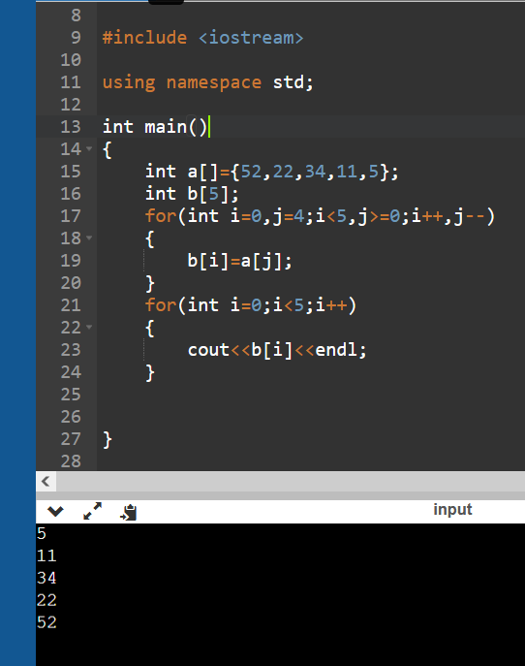

=>#include <iostream>

using namespace std;

int main()

{

int a[]={52,22,34,11,5};

int t;

for(int i=0,j=4;i<j;i++,j--)

{

t=a[i];

a[i]=a[j];

a[j]=t;

}

for(int i=0;i<5;i++)

{

cout<<a[i]<<endl;

}

}

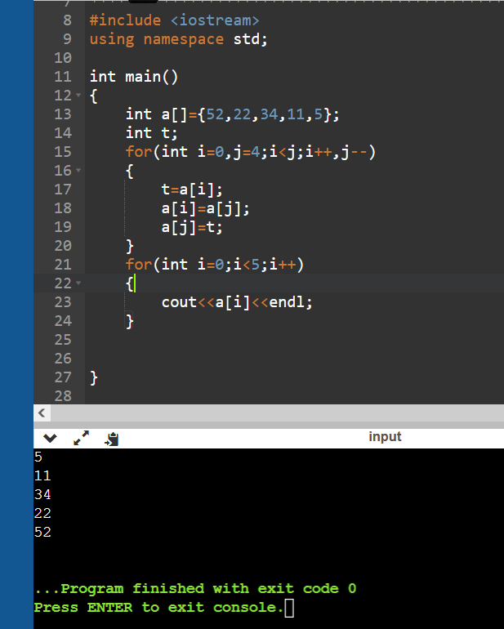

Q) Merging of an array.

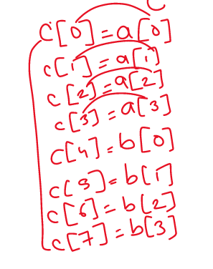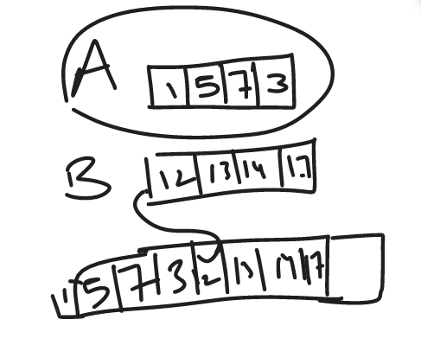

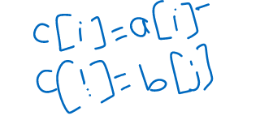

=> #include<iostream>

using namespace std;

int main()

{

int a[]={1,3,5,8,9};

int b[]={11,22,33,44};

int s1,s2,s3;

s1=5;s2=4;s3=s1+s2;

int c[s3];

for(int i=0;i<s1;i++)

{

c[i]=a[i];

}

for(int i=s1,j=0;i<s3,j<s2;i++,j++)

{

c[i]=b[j];

}

for(int i=0;i<s3;i++)

{

cout<<c[i]<<endl;

}

}

